Technical Documentation

US Disaster Declarations Dashboard using Microsoft Power BI
Prepared By: Yash Nandekar

1. Project Overview
Objective
The objective of this project is to develop an interactive Power BI dashboard that analyzes FEMA disaster declarations across the United States. The dashboard enables users to monitor disaster trends, geographic distribution, declaration programs, incident types, and perform scenario analysis using a What-If parameter. The solution is designed using a Star Schema data model, Power Query for data preparation, and DAX measures for analytical calculations.

2. Dataset Information
Attribute | Details
Dataset Name | US Disaster Declarations
Source | FEMA Disaster Declaration Dataset
File Format | CSV
Total Records | 64,091
Number of Columns | 20 (after data cleaning)
Tool Used | Microsoft Power BI Desktop

3. Entity Relationship Diagram (ERD)
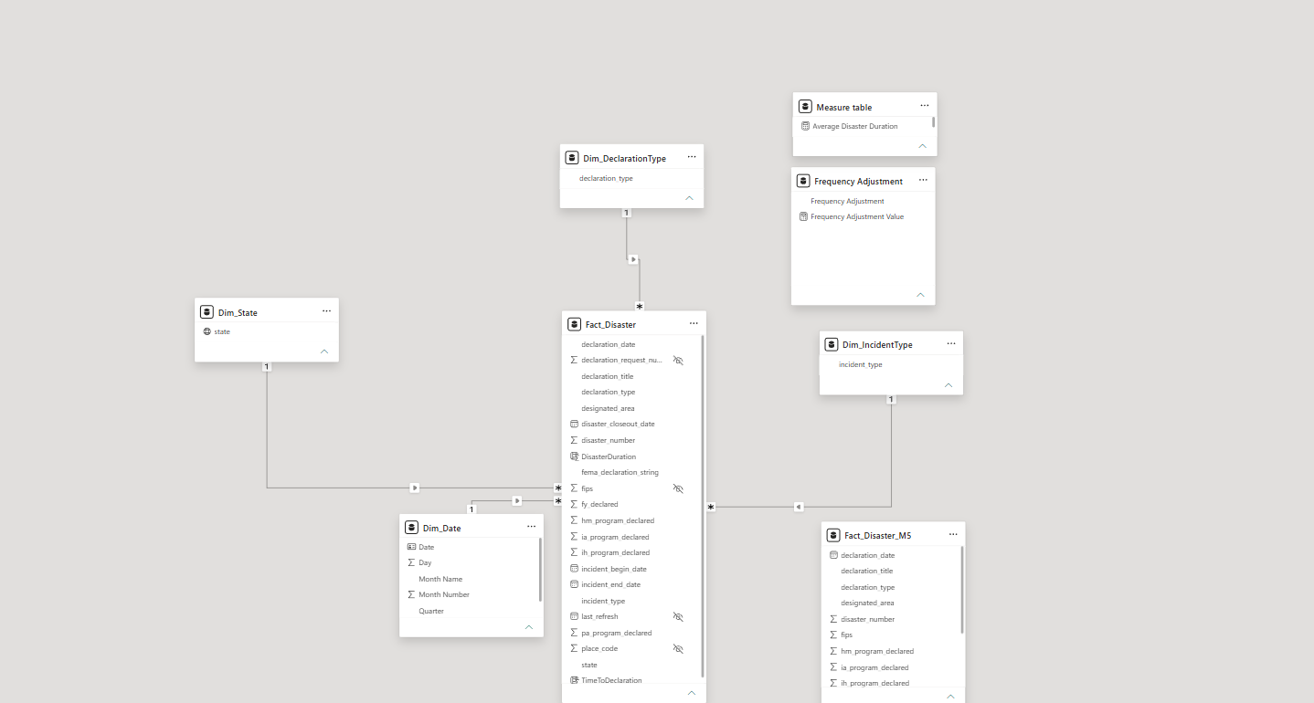Data Model
The dashboard follows a Star Schema consisting of one fact table and multiple dimension tables.
Fact Table
- Fact_Disaster
Dimension Tables
- Dim_Date
- Dim_State
- Dim_IncidentType
- Dim_DeclarationType
Relationships
From | To | Relationship
Fact_Disaster[state] | Dim_State[state] | Many-to-One
Fact_Disaster[declaration_date] | Dim_Date[Date] | Many-to-One
Fact_Disaster[incident_type] | Dim_IncidentType[incident_type] | Many-to-One
Fact_Disaster[declaration_type] | Dim_DeclarationType[declaration_type] | Many-to-One

4. Power Query Data Cleaning (M Transformations)
The dataset was cleaned and transformed using Power Query before loading it into the Power BI data model.
Data Cleaning Steps
Step | Description
Import CSV | Imported FEMA disaster declaration CSV dataset into Power BI.
Promoted Headers | Converted the first row into column headers.
Removed Columns | Removed unnecessary columns such as id, hash, and last_ia_filing_date.
Trimmed Text | Removed leading and trailing spaces from text fields.
Cleaned Text | Removed non-printable and special characters from text columns.
Replaced Invalid Values | Replaced invalid values (e.g., NA) with null before date conversion.
Changed Data Types | Assigned appropriate data types to numeric, date, and text columns.
Locale Conversion | Converted declaration_date using English (United Kingdom) locale.
Numeric Conversion | Converted IA, PA, HM, and IH declaration fields into Whole Number format.

5. DAX Measures
The following DAX measures were created to support dashboard calculations.
Measure | Description
Total Disaster Declarations | Counts all disaster declarations.
Total IA Declarations | Counts Individual Assistance declarations.
Total PA Declarations | Counts Public Assistance declarations.
Total HM Declarations | Counts Hazard Mitigation declarations.
Total Incident Types | Counts distinct incident types.
Total States Affected | Counts unique affected states.
Average Disaster Duration | Calculates the average duration of disasters.
Average Time To Declaration | Calculates the average number of days between incident start and declaration.
Frequency Adjustment Value | Stores the selected What-If parameter value.
Projected PA Funding | Calculates projected Public Assistance funding based on the selected adjustment percentage.
Projected IA Declarations | Estimates IA declarations based on the selected scenario.
Projected PA Funding (Scenario Chart) | Generates projected funding values for the scenario analysis line chart.

6. Dashboard Pages

Page 1 – Executive Overview
Displays high-level KPIs including:
- Total Disaster Declarations
- Total IA Declarations
- Total PA Declarations
- Total HM Declarations
- Average Disaster Duration
- Trend charts

Page 2 – Geographic Analysis
Displays disaster declarations by state using:
- Filled Map
- State-wise Bar Charts
- Geographic Filters

Page 3 – Temporal Trends
Analyzes disasters over time using:
- Line Charts
- Column Charts
- Area Charts
- Matrix

Page 4 – Incident & Program Insights
Analyzes disaster types and FEMA assistance programs using:
- Scatter Chart
- Clustered Bar Chart
- Matrix
- Column Chart

Page 5 – Scenario Analysis
Provides interactive forecasting using:
- What-If Parameter
- Projected Funding Cards
- Projected Declaration Cards
- Scenario Analysis Line Chart

7. Updating the Dataset
When FEMA publishes new disaster declaration data, the dashboard can be updated using the following process:
- Download the latest FEMA disaster declaration CSV dataset.
- Replace the existing CSV file with the updated file while keeping the same file name and folder location.
- Open the Power BI Desktop (.pbix) project.
- Click Home → Refresh.
- Verify that all visuals refresh successfully.
- Save the Power BI report.
- Validate KPIs and charts before publishing the updated report.

8. Publish to Power BI Service
The completed dashboard can be deployed to Power BI Service for online access and collaboration.

Step 1 – Upload the Report
- Open the completed .pbix file in Power BI Desktop.
- Sign in using a Microsoft organizational (work or school) account.
- Click Home → Publish.
- Select the desired workspace (e.g., My Workspace or a team workspace).
- Wait for the report and semantic model (dataset) to be published successfully.

Step 2 – Configure Workspace Permissions
After publishing:
- Open Power BI Service.
- Navigate to the workspace containing the report.
- Select Manage Access.
- Add users or user groups who require access.
- Assign appropriate roles:
  - Viewer – Can view reports only.
  - Contributor – Can edit reports and datasets.
  - Member – Can publish, edit, and manage content.
  - Admin – Full workspace administration.
This ensures that only authorized users can access or modify the dashboard.

Step 3 – Configure Scheduled Refresh
To keep the dashboard synchronized with newly published FEMA data:
- Open the published Semantic Model (Dataset) in Power BI Service.
- Select Settings.
- Configure the required data source credentials.
- Enable Scheduled Refresh.
- Set the refresh frequency (for example, Monthly, depending on Power BI Service capabilities and organizational policy).
- Select the desired refresh day and time.
- Save the configuration.
- Monitor refresh history to confirm successful updates.

Note
This project was fully developed and validated in Power BI Desktop. Actual deployment to Power BI Service requires a Microsoft organizational (work or school) account. Since such an account was not available during development, the deployment process has been documented as part of the project deliverables.

9. Performance Optimization
The dashboard was optimized using the following techniques:
- Implemented a Star Schema data model.
- Removed unnecessary columns from the dataset.
- Assigned appropriate data types to improve query performance.
- Created dedicated DAX measures instead of calculated columns where appropriate.
- Organized measures into a separate Measure Table.
- Hid unused columns from Report View to simplify the data model.
- Reduced slicer complexity using dimension tables.
- Verified dashboard refresh performance on the complete dataset (~64,000 records).

10. Assumptions and Limitations
- Missing or invalid date values are treated as null.
- The What-If parameter provides simulation-based projections only and does not modify the source data.
- Dashboard accuracy depends on the correctness of the source FEMA dataset.
- The dataset structure should remain consistent when replacing the CSV file with future updates.

11. Conclusion
The US Disaster Declarations Dashboard provides a comprehensive analytical solution for exploring FEMA disaster declaration data. By integrating Power Query transformations, a star schema data model, DAX calculations, and interactive visualizations, the dashboard enables users to identify disaster trends, compare assistance programs, analyze geographic impacts, and perform scenario-based forecasting through the What-If parameter. The solution is designed to support future data updates and can be deployed to Power BI Service for collaborative reporting when an organizational account is available.

